Telegram Development

# Environment

|  |  |  |
| --- | --- | --- |
| Description | Staging | Production |
| Database | | |
| * Host | 172.18.185.131 | 172.18.182.87 |
| * Username/password | user01/edts321 | User01/P@ssw0rd |
| * Provider/Version | Mysql/5 | Mysql/5 |
| * name | indomarco-tms | indomarco-tms |
| * username/password DB | idmapps/edts321 | adminedtstms/adminedts321! |
| Kubernetes | | |
| Node 1 | 172.18.185.110 | 172.18.181.84 |
| Node 2 |  | 172.18.181.85 |
| Node 3 |  | 172.18.182.86 |
| Username/password | user01/edts321 | User01/P@ssw0rd |
| Path file Apps | /home/user01/puguh/tms-source-kube | /home/user01/telegram-source-kube |
| Path file NFS | /home/user01/nfs-provisioner | /home/user01/nfs-provisioner |
| Link create storage nfs | ttps://geoffreymahugu.medium.com/kubernetes-bare-metal-dynamic-storage-allocation-e5311ac45909 | |
| Volume dan NFS Store | | |
|  | 172.18.185.131 | 172.18.182.87 |
|  |  |  |
| Repository | | |
|  | https://bitbucket.org/edts/edts-telegram/src/production/ | https://bitbucket.org/edts/edts-telegram/src/production/ |
| Docker Hub | | |
|  | 369693/tms-best | 369693/tms-bepr |

# Dokumen

* Postman Collection <https://documenter.getpostman.com/view/12810761/TzeWHTyo>
* Xample json (notepat terlampir)
* Class Model (File contact class diagram, message class diagram terlampir)
* Kubernetes file (terlampir)

# Runing Local

1. Contoh : git clone <https://username@bitbucket.org/edts/edts-telegram.git>
2. git checkout -b dev-test
3. ikuti langkah di sini <https://tdlib.github.io/td/build.html>, untuk generate tdlib jni telegram.
4. jalankan printah : **mvn spring-boot:run -P local,** atau bisa dari IDE yg dipakai.

# Deployment

1. Pull request dari repository bitbucket
2. Cek di docker hub
3. Masuk Ke server edit file tms-depolyment-volume.yaml

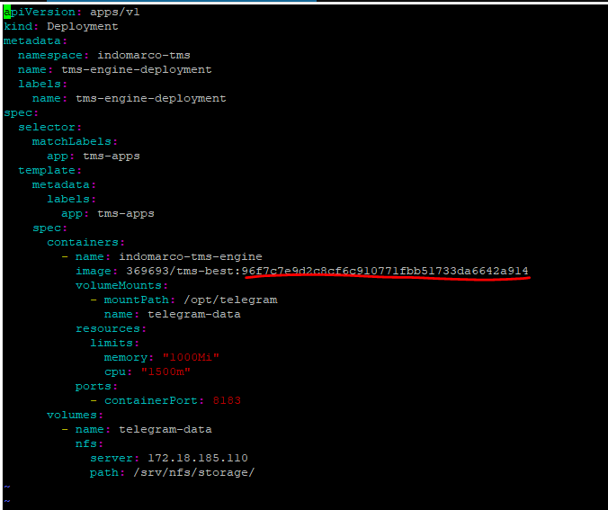

Yg di garis bawah merah, ganti dari dockerhub, gambar di bawah

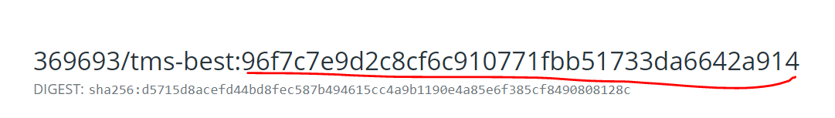

1. Setelah fix di ganti, jalankan perintah

***kubectl get deployment -n indomarco-tms***

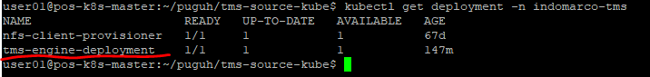

1. Khusus untuk staging delete dulu deployment yg di garis merah di point no.4, dengan perintah *kubectl delete deployment tms-engine-deployment -n indomarco-tms*
2. Terkahir jalankan *perintah kubectl apply -f tms-deployment-volume.tms*
3. Makesure deployment sukses

***kubectl get deployment -n indomarco-tms***

***kubectl get pods -n indomarco-tms***

***kubectl logs ‘id dari get pods di atas’ -n indomarco-tms***

1. Untuk production untuk langkah no. 5 tidak harus di lakukan.

# Pre Move

**SELECT** * **from** system_configuration sc;

**SELECT** * **from** telegram_account ta;